**An Analysis of the Factors Influencing Standardized Readmission Ratio (SRR) at Dialysis Facilities in the United States**

Nicholas Milikich

University of Notre Dame

# Abstract

For kidney disease patients undergoing dialysis, the standardized readmission ratio, the number of hospital readmissions within 30 days of discharge from a prior hospitalization (due to a comorbidity of kidney disease) relative to the national median of patients with the same characteristics, is a marker of overall care quality and is used as a pay-for-performance metric for treatment reimbursements. The factors affecting SRR at the individual level are well-characterized, but those at the facility level are not, which should be of interest to owners of dialysis facilities. A dataset of 58 metrics on 6,068 observations (facilities) was analyzed by fitting the following to classify SRR with a cut score of 1 and 1.2072: lasso and elastic net regression for variable selection, decision trees to observe important variables and interactions, a random forest to examine variable influence, and a boosting random forest to identify variable interactions. Correlations were identified between similar measurements (e.g. PctgUFRGT13 and AvgUFR) and interactions were identified between variables with likely causal relationships (e.g. Network and biological markers such as PctgFluVaccine or AvgKtV), presenting the possibility of creating new variables using linear or nonlinear combinations of similar or related variables. A total of five biological marker variables (AvgHemoglobin, AvgKtV, PctgESAPrescribed, PctgFluVaccine, PctgHemoglobin10) and five demographic variables (Network, PctgBlack, TotalPatients, TotalStaff, Urbanicity2) were chosen for nodes in decision trees. It is likely that these demographic variables are responsible for both poor performance on biological metrics and on SRR, and it might be advantageous for owners of dialysis facilities to invest in facilities in lower-income areas to improve quality of care, performance, and reimbursement. However, the high degree of variability makes it difficult to identify trends and nearly impossible to predict outcomes.

# Introduction

Patients with chronic kidney failure (CKF) or end-stage renal disease (ESRD) must undergo hemodialysis several times per week, a treatment that filters wastes from the blood and can be performed either at home or in a dialysis center (Romancito, 2018). However, the severity of the disease means that it carries numerous comorbidities, and patients are frequently hospitalized for auxiliary conditions. Patient 30-day hospital readmission rates have been analyzed to identify trends in the timing of patient readmissions and readmission diagnoses (Hickson et al., 2018), and factors that contribute to higher readmissions have been identified including age, gender, ability, biological markers, presence of specific comorbidities, and duration of time on dialysis (Hickson et al., 2018; Chan et al., 2017).

The frequency of 30-day hospital readmissions can also be assessed at the facility level. The most common such metric is the standardized readmission ratio (SRR), which is the number of hospital readmissions for patients at a facility, relative to the number that would be expected given the characteristics of the patients at that facility and national average rates (“Report for the standardized…,” 2017). More specifically, the denominator of this ratio is “the number of readmission events that would be expected if patients at that facility experienced readmission events at the national median rate for patients with similar characteristics” (“Report for the standardized…,” 2017, pg. 4).

The factors affecting hospital readmissions at the individual level have been well-characterized (Hickson et al., 2018; Chan et al., 2017); they are so well trusted, in fact, that the official SRR metric is standardized with respect to the number of hospital readmissions that might be expected among a facility’s patients given their individual comorbidity histories (“Report for the standardized…,” 2017). However, little analysis has been done into the factors that affect patient hospital readmission rates at the facility level. Such research should be of great interest: the SRR is a pay-for-performance quality measure implemented by the Centers for Medicare and Medicaid Services to incentivize a reduction in hospital readmissions (Assimon & Flythe, 2017). It is of interest to operators of dialysis facilities to understand what metrics and facility-wide practices contribute to a higher SRR in order to reduce SRR and be eligible for greater government insurance reimbursement payments. This study applies a variety of machine learning techniques to previously compiled data on American dialysis facilities (Wang, 2018) in order to characterize the factors affecting SRR at the facility level.

## Methods

A dataset of 58 metrics on 6,574 dialysis facilities across the United States was taken from a publicly available dataset on Kaggle; it was compiled by blending data from a number of other publicly available datasets including ESRD Quality Incentive Program (QIP) Payment Year (PY) 2018 Dataset and Dialysis Facility Report 2018 (Wang, 2018). Incomplete entries were excluded from the dataset, resulting in 6,068 observations of 58 variables.

Initially, five variables which were identificatory and not expected to have any relationship to SRR—CCN (CMS Certification Number), Name, City, ZipCode, and State—were removed from the dataset.

For further analyses, a cut score of 1 was used to create a binary classification of SRR values as being above (worse performance) or below (better performance) the national median. To reduce the number of variables, a lasso and elastic net were performed using the glmnet package in R. The lasso penalizes parameters based on their absolute value and performs well with variable selection, while the elastic net evenly weights penalties from lasso regression and ridge regression—which penalizes parameters based on their square and performs well with identifying collinearities. To address both variable selection and collinearity concerns, only variables selected by both methods were kept in the dataset. A decision tree (CART) and conditional inference tree were fit using the caret package in R, followed by a random forest to examine variable importance. The accuracy of the random forest was assessed using 10-fold cross-validation to assess potential overfitting. Finally, a boosting random forest was fit in order to identify variable interactions.

The steps in the preceding paragraph were repeated starting with the complete data set with only the identificatory variables excluded using an SRR cut score of 1.2072, the score above which facilities are in the worst performing 20% (a proportion admittedly chosen somewhat arbitrarily) of facilities examined. Additionally, a principal component analysis was performed on the full dataset of 53 variables.

**Results**

The variables selected using a lasso and elastic net for predicting SRR with a cut score of 1 are listed in figure 1. The lasso performs better for variable selection, while the elastic net takes into account collinearity as well; it therefore generally provides solutions that are not as sparse as with lasso regression. The elastic net chooses 3 extra variables not chosen by the lasso (PctgAge18, PctgHemoglobin10t11, and UnemploymentRate), and it does not choose PctgUFRGT13 which was chosen by the lasso, suggesting that PctgUFRGT13 interacts with another variable. To provide a sparser model, only variables chosen by both methods were kept in the model.

The CART decision tree for predicting SRR with a cut score of 1 is shown in figure 2. The accuracy of this tree is 0.5920, while the proportion of 0’s in the response is 0.5109. Overall, this tree does not appear to be a very strong classifier, as the most homogeneous terminal node contains less than 70% 0’s. However, it is interesting that PctgBlack is the only variable necessary to make the strongest classification, hinting at the relative importance of this variable. The conditional inference tree for predicting with a cut score of 1 is shown in figure 3. This tree appears visually to be a stronger classifier, as several of the terminal nodes are more homogeneous, being composed of at least 70% 0’s or 1’s; however, the performance of this tree is actually worse, with an accuracy of 0.5819. It is also notable that although this tree is larger, only 2 of the 4 variables that appeared in the CART appear in this tree.

The variable importance values from running a CART random forest with cut score of 1 are shown in figure 4. This model demonstrates perfect classification accuracy, but the 10-fold cross-validated classification accuracy of 0.5857 is comparable to that of the individual trees. This suggests that the random forest is extremely overfit to the given data and should not be considered reliable for prediction, although its results should still be informative to use for the purpose of interpretation. PctgBlack is assigned the highest variable importance score, in agreement with its demonstrated importance in the individual CART. The only other variables with VIP scores over 50 are PctgHemoglobin10 and PctgKtVOther, both biological markers. The relative influence of each variable is shown in figure 5; the variable with the highest relative influence is Network, a geographic factor variable not yet selected by any other algorithm. The following 6 variables in terms of influence were all chosen by other methods. The variable interactions are shown in figure 6 and reveal strong interactions between Network and five other variables (PctgFluVaccine, AvgKtV, AvgHemoglobin, PctgFistula, and TotalStaff), perhaps explaining the apparent incongruity between the relative influence of Network and its absence in any variable selection procedure.

The variables selected using a lasso and elastic net for predicting SRR with a cut score of 1.2072 are listed in figure 7. It in unexpected for the elastic net to produce a sparser model than the lasso, but its exclusion of ChainOwner likely indicates an interaction between that variable and at least one other. Using this cut score resulted in a variable selection with a greater proportion of biological markers and a lower proportion of demographic data. Again, only variables chosen by both methods were kept in the model.

The CART decision tree for predicting SRR with a cut score of 1.2072 is shown in figure 8. The tree has only one node, so the accuracy of the tree is the same as the proportion of 0’s in the response, 0.7999. The conditional inference tree for predicting with a cut score of 1.2072 is shown in figure 9. Although this tree is allowed to grow to 15 nodes, the accuracy is identical to that of the previous one-node tree (0.7999).

The variable importance values from running a CART random forest with a cut score of 1.2072 are shown in figure 10. This model too demonstrates perfect classification accuracy, but again the 10-fold cross-validated classification accuracy of 0.7998 is comparable to that of the individual trees, suggesting the random forest is overfit as before. The highest variable importance score is assigned to PctgKtVOther, followed by two factors of Network, AvgHemoglobin, PctgBlack, AvgKtV, PctgFluVaccine, PctgKtV18, PctgESAPrescribed, and PctgNonMedicare. With a cut score of 1.2072, there are many more variables with relatively high variable importance (greater than 50), in accordance with the general difficulty seen in using the given variables to predict SRR as observed in the decision trees. The relative influence of each variable is shown in figure 11, and the variable interactions are shown in figure 12, demonstrating the same trends as with a cut score of 1.

The loadings for the principal component analysis are shown in figure 13. Using the rule of thumb that enough components should be retained to explain 95% of the variation suggests that 14 components should be used. A certain subset of the variables (most of which were also chosen by other models) seem to load onto several of the components, while several of the variables do not load onto any components and appear to have little relevance.

**Discussion**

To begin, the identified variable interactions will be discussed. No decision trees identified any variable interactions as no tree ever split on the same variable more than once. An interaction between PctgUFRGT13 (percentage of patients with an ultrafiltration rate greater than 13 mL/h/kg) and some other variable was suggested from the results of the lasso and elastic net with a cut score of 1; however no interactions were identified between PctgUFRGT13 and any other variable from boosting. Strong interactions were identified between Network and each of PctgFluVaccine, AvgKtV, AvgHemoglobin, PctgFistula, and TotalStaff, suggesting that the performance of dialysis facilities differs based on geographic location. More precisely, this suggests that a facility’s Network, or geographic location, impacts the effect of these other variables on SRR (performance). Similarly, an interaction between ChainOwner and some other variable was suggested by the results of the elastic net with a cut score of 1.2072, and it is likely that ChainOwner interacts with a number of variables in a similar manner to Network, although perhaps not as strongly. It seems that it is difficult to separate dialysis performance from demographic factors that might be affecting performance, such as patient education and income, which would in turn impact overall patient health, etc.

The variables chosen for nodes in each of the four decision trees created are shown in table 1 organized into variables that describe biological markers and those that describe demographic data. In terms of biological markers, facilities whose patients have a higher average hemoglobin count (AvgHemoglobin) and higher average Kt/V (clearance time per volume, AvgKtV) tend to experience a lower SRR (better performance). Facilities with a lower percentage of patients with low hemoglobin (PctgHemoglobin10), a lower percentage of patients who have been prescribed erythropoietin-stimulating agents to treat erythropoietin-deficient anemia related to CKD (PctgESAPrescribed), and a higher percentage of patients who have received their flu vaccine (PctgFluVaccine) tend to experience a lower SRR. The inclusion of these metrics as opposed to the many others in the complete data set suggests that dialysis facilities might closely monitor patients who have or are at risk for anemia (in addition to the performance of their dialysis procedures in the form of clearance time per volume and the overall health of their patients in the form of patient vaccination) in order to improve care and lower their SRR.

In terms of demographic data, facilities with a lower percentage of black patients (PctgBlack), fewer total patients (TotalPatients) and total staff (TotalStaff), facilities that are rural (Urbanicity2), and facilities in certain networks (Network) tend to experience a lower SRR. It appears counterintuitive that facilities with smaller staffs have better performance, but it is likely that facilities that are smaller simply tend to perform better. These demographic data are certainly not causal with respect to SRR; it is more likely that these underlying demographic variables are responsible for both poor performance on biological metrics and on SRR. It might be advantageous, at the risk of stating the obvious, for owners of dialysis facilities to invest in their facilities in lower-income areas in order to improve patient care and facility performance as assessed by SRR.

It is difficult to draw any conclusions from the principal component analysis. Rather than loading onto components made up of variables that are related in some way, components 2 through 14 appear to be quite homogeneous, made up of seemingly random combinations of a subset of all variables—mostly variables that other models had already indicated as being important. It is likely that recoding categorical variables as numerical for the purpose of the principal component analysis disrupts any patterns that might have been present.

Overall, the variability in the data is such that it is extremely difficult to fit any model that predicts SRR with any reasonable efficiency. For example, with a cut score of 1.2072 no decision trees were found that raised the classification accuracy of SRR over that of a null model. Individual patients already represent a great deal of variability, and when adding across patients at the facility level it seems that the variability becomes so great that it remains possible to identify some trends but becomes nearly impossible to predict new cases with any useful accuracy. It is likely that creating binary data using a cut score added a level of artificial noise to the data—for example, by introducing a difference between facilities with SRR scores of 0.999 and 1.001. Initially fitting decision trees to a continuous response proved difficult, as most terminal nodes were relatively homogeneous (had mean SRR scores close to 1) which did a poor job of modeling data with scores far above or below 1. Since these cases were the focus of this study, a binary method was adopted, but it might prove fruitful to return to modeling with a continuous response.

Moving forward, both for simplicity of prediction and to reduce some of the variability, it might be useful to investigate how variables describing similar measurements might be grouped. For example, there are six variables in the dataset all relating to hemoglobin/anemia; some linear or nonlinear combination of the variables AvgHemoglobin, PctgHemoglobin10, PctgHemoglobin10t11, PctgHemoglobin11t12, PctgHemoglobin12, and PctgESAPrescribed might be added to the model as a measure of overall patient health as it relates to hemoglobin/anemia.

Finally, it might also be beneficial to add a longitudinal component to the analysis. The reports used to create this dataset are published yearly, so it would be simple to track each facility’s performance on these metrics over time. This might allow for an analysis of what factors are predictive of or associated with an improvement or decline in SRR performance over time.

# References

Assimon, M. M., & Flythe, J. E. (2017). Thirty-day hospital readmissions in the hemodialysis population: A problem well put, but half-solved.*Clinical Journal of the American Society of Nephrology : CJASN, 12*(10), 1566-1568. doi:10.2215/CJN.08810817

Chan, L., Poojary, P., Saha, A., Chauhan, K., Ferrandino, R., Ferket, B., et al. (2017). Reasons for admission and predictors of national 30-day readmission rates in patients with end-stage renal disease on peritoneal dialysis.*Clinical Kidney Journal, 10*(4), 552-559. doi:10.1093/ckj/sfx011

Hickson, L., Thorsteinsdottir, B., Ramar, P., Reinalda, M., Crowson, C., Williams, A., et al. (2018). Hospital readmission among new dialysis patients associated with young age and poor functional status.*Nephron, 139*(1), 1-12. doi:10.1159/000485985

*Report for the standardized readmission ratio* (2017). The University of Michigan Kidney Epidemiology and Cost Center.

Romancito, G. (2018). *Hemodialysis.* Retrieved 7 Nov, 2019, from https://www.niddk.nih.gov/health-information/kidney-disease/kidney-failure/hemodialysis

Wang, J. (2018). *RMU dissertation - final data file* Kaggle, Inc.,

from https://www.kaggle.com/wcj365/rmudsc2

# Appendix 1: Figures and Tables

|  |  |
| --- | --- |
| 1. Lasso   PctgBlack  Network  AvgSerumPhosphorous  PctgFistula  PctgCatheterOnly90  TotalPatients  PctgMedicare  PctgNonMedicare  ProfitStatus  ChainOwner  PctgFluVaccine  AvgHemoglobin  PctgHemoglobin10  PctgESAPrescribed  PctgUFRGT13  AvgKtV  PctgKtV18  PctgKtVOther  PctgPoorEnglish  HospitalAffiliation  Urbanicity2 | 1. Elastic Net   PctgAge18  PctgBlack  Network  AvgSerumPhosphorous  PctgFistula  PctgCatheterOnly90  TotalPatients  PctgMedicare  PctgNonMedicare  ProfitStatus  ChainOwner  PctgFluVaccine  AvgHemoglobin  PctgHemoglobin10  PctgHemoglobin10t11  PctgESAPrescribed  AvgKtV  PctgKtV18  PctgKtVOther  UnemploymentRate  PctgPoorEnglish  HospitalAffiliation  Urbanicity2 |

Figure 1: Variable Selection for lasso (a) and elastic net (b) for SRR cut score 1.

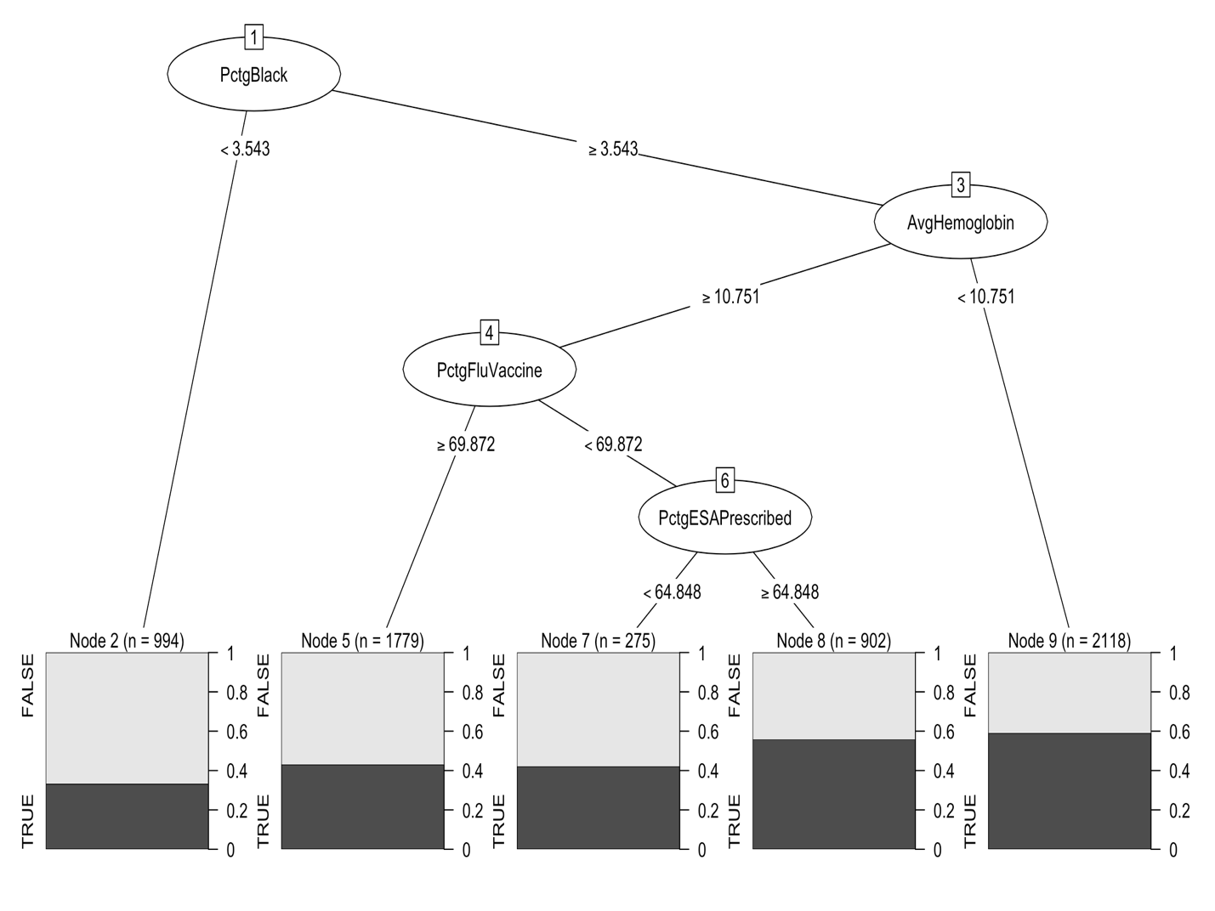

Figure 2: CART Decision Tree for SRR cut score 1.

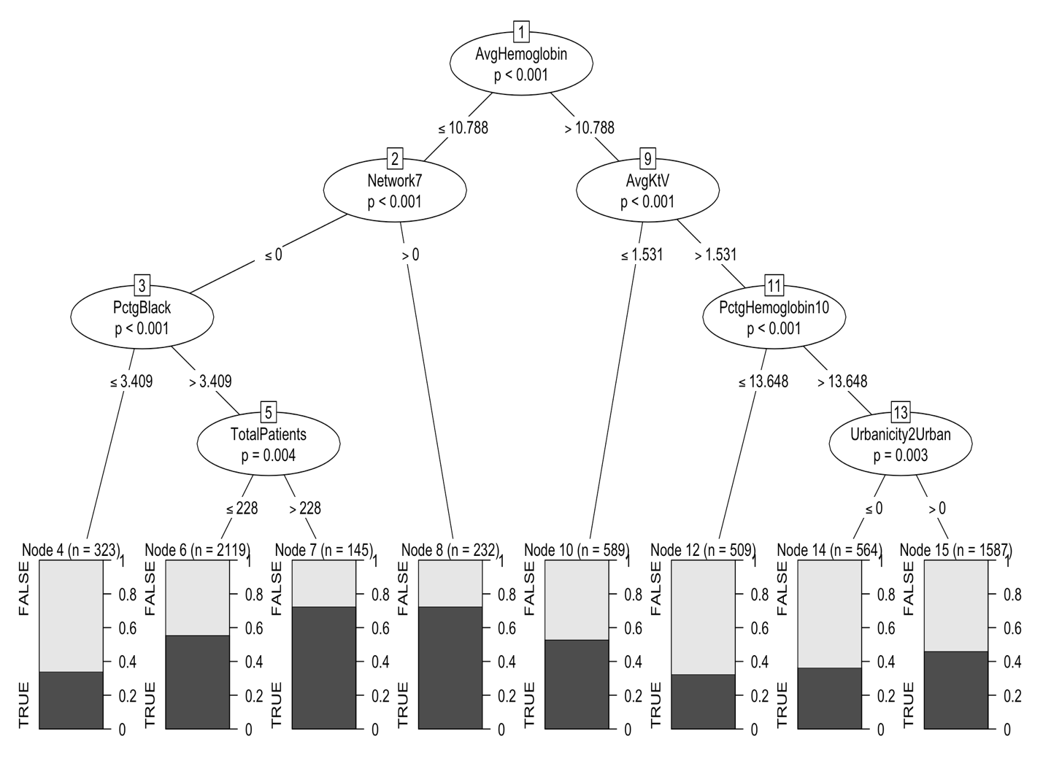

Figure 3: Conditional Inference Tree for SRR cut score 1.

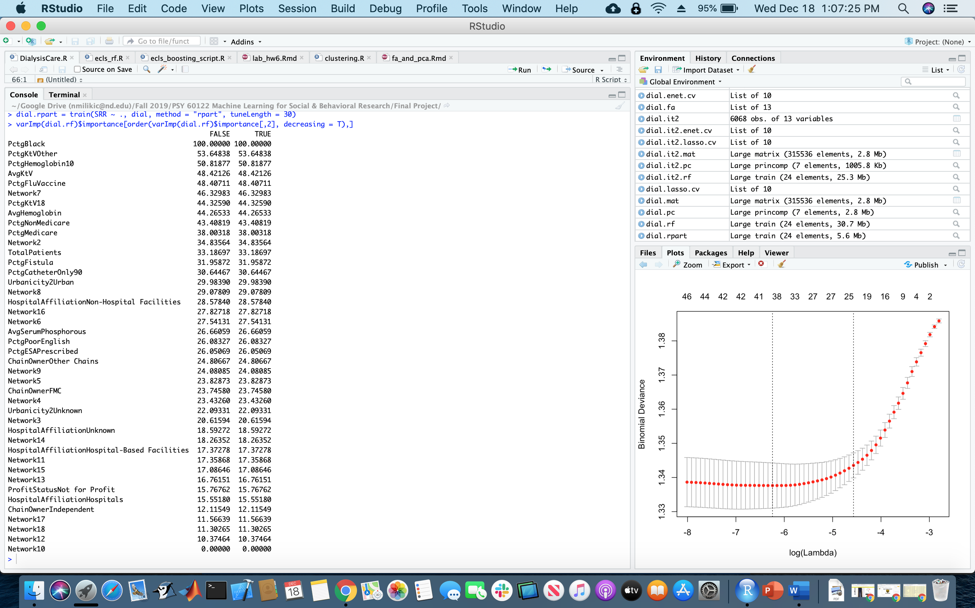

Figure 4: Variable Importance from CART Random Forest with SRR cut score 1.

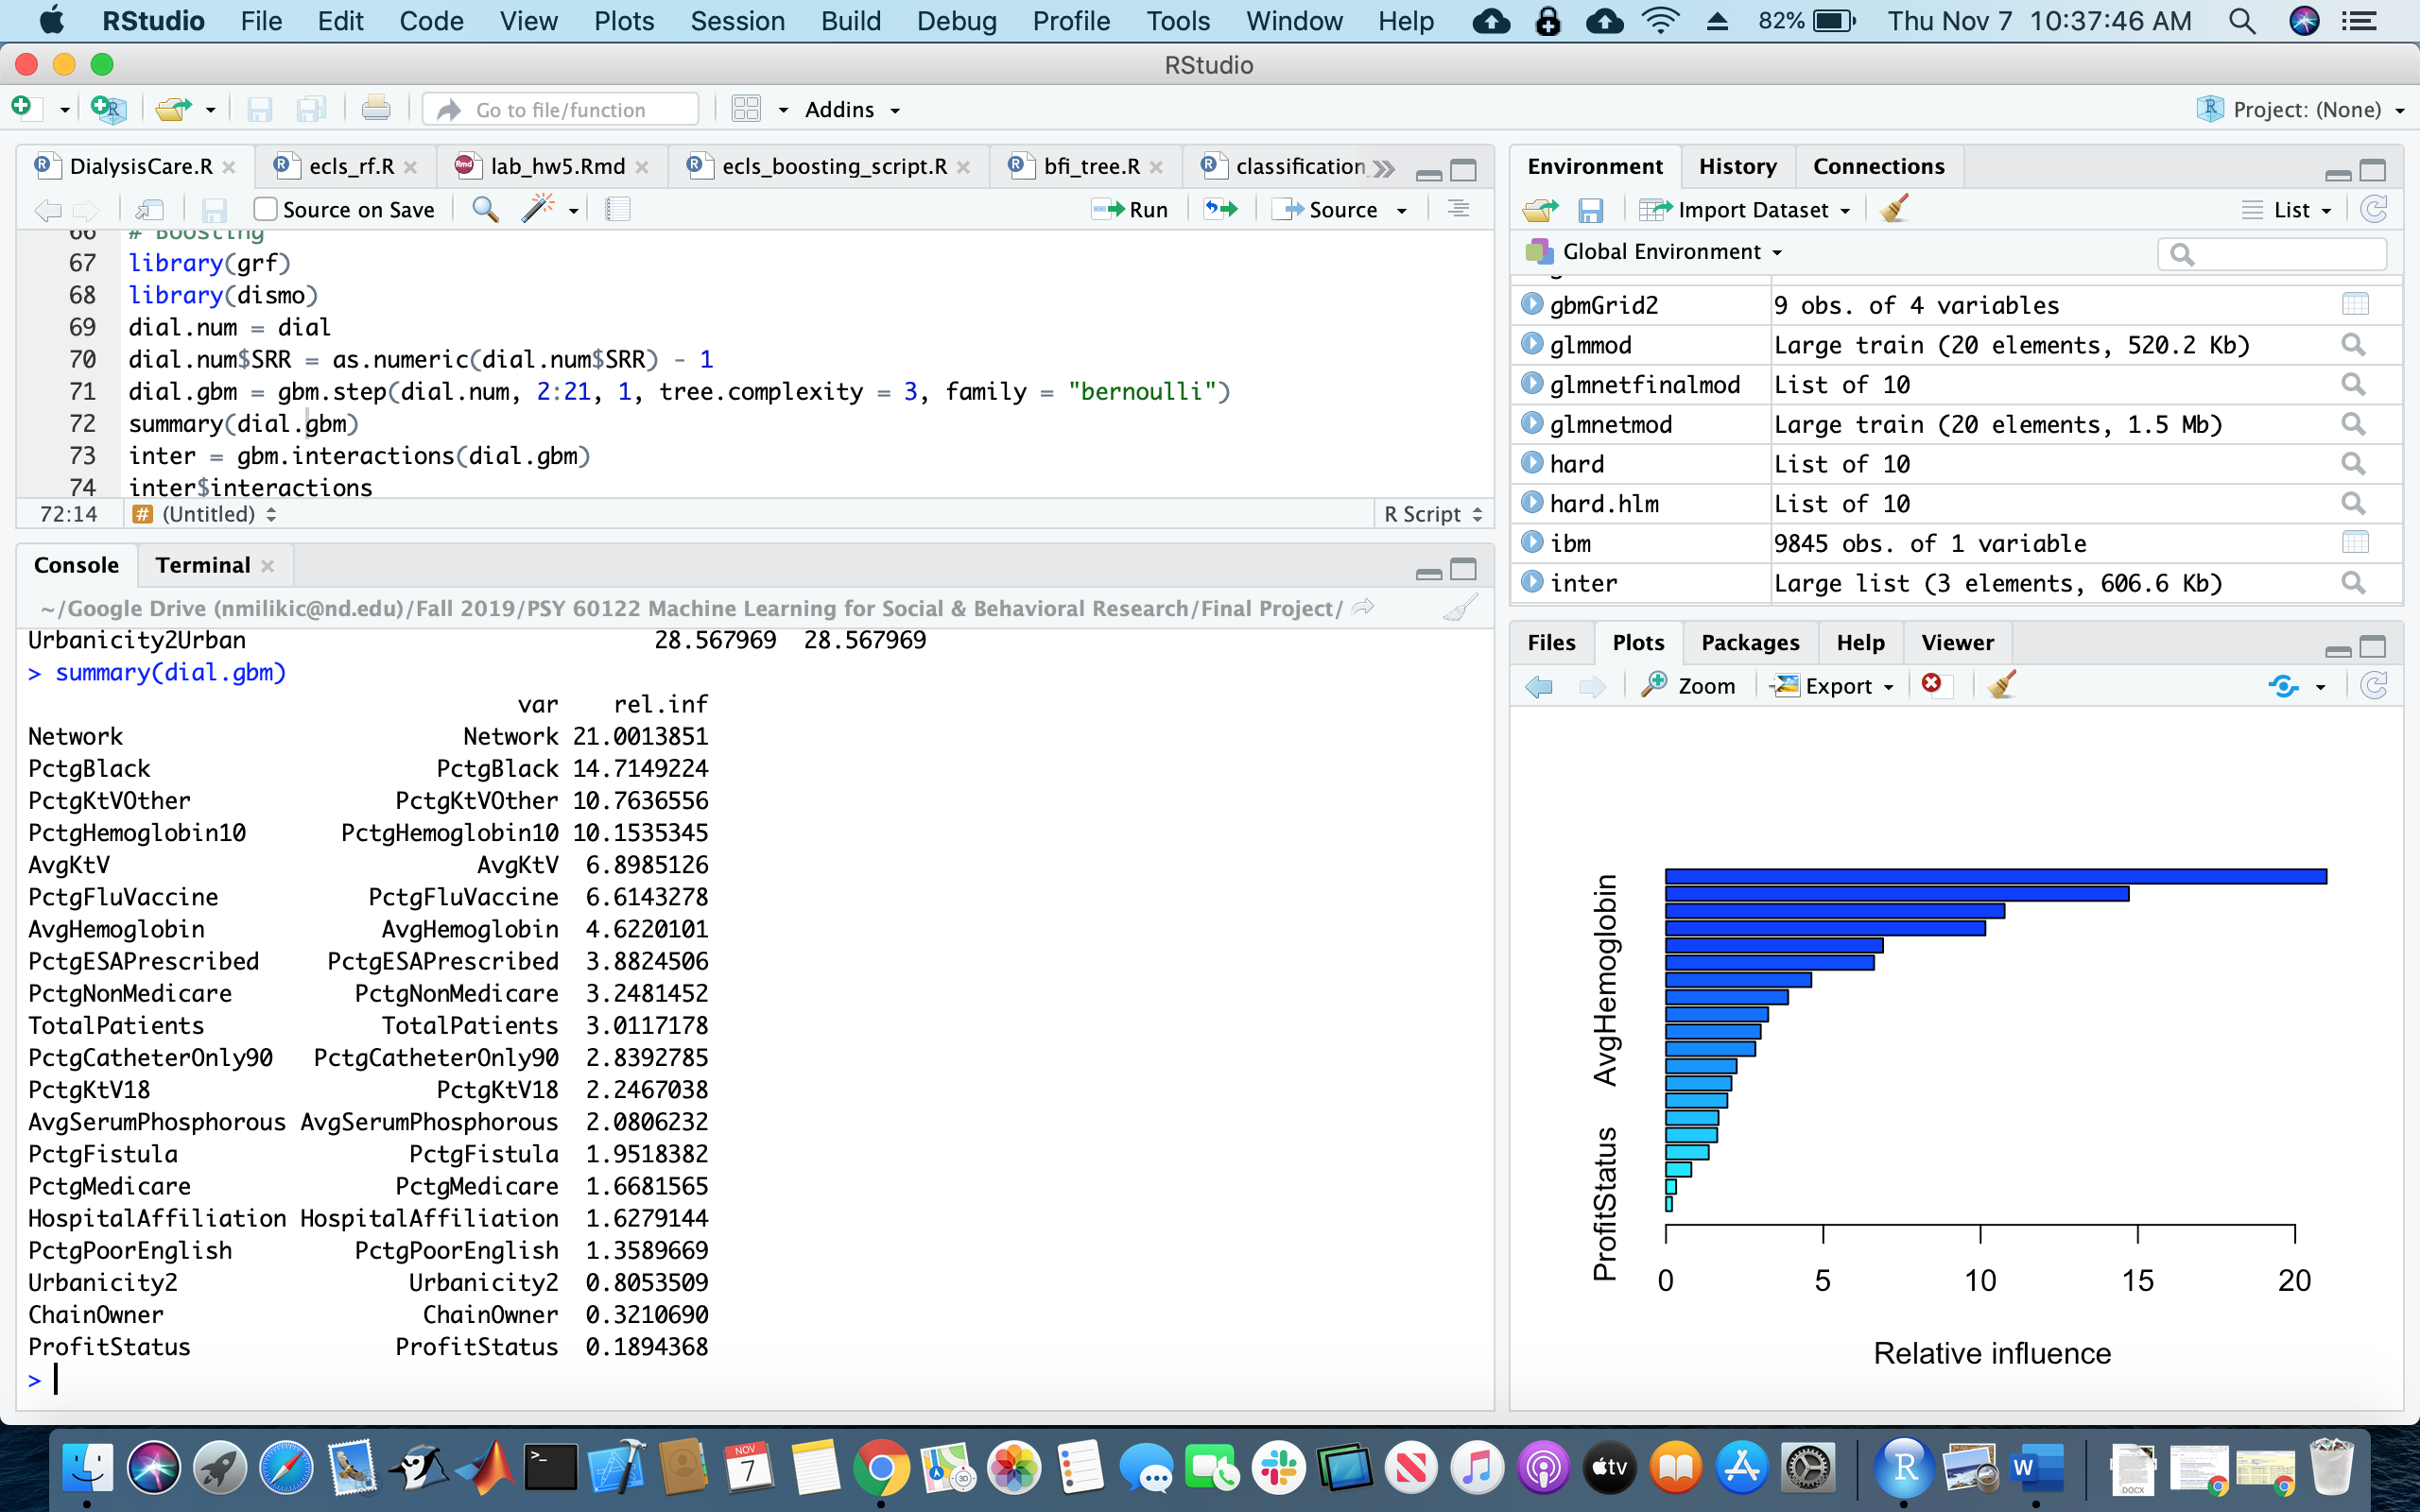

Figure 5: Relative Influence of Each Variable from Boosting with SRR cut score 1.

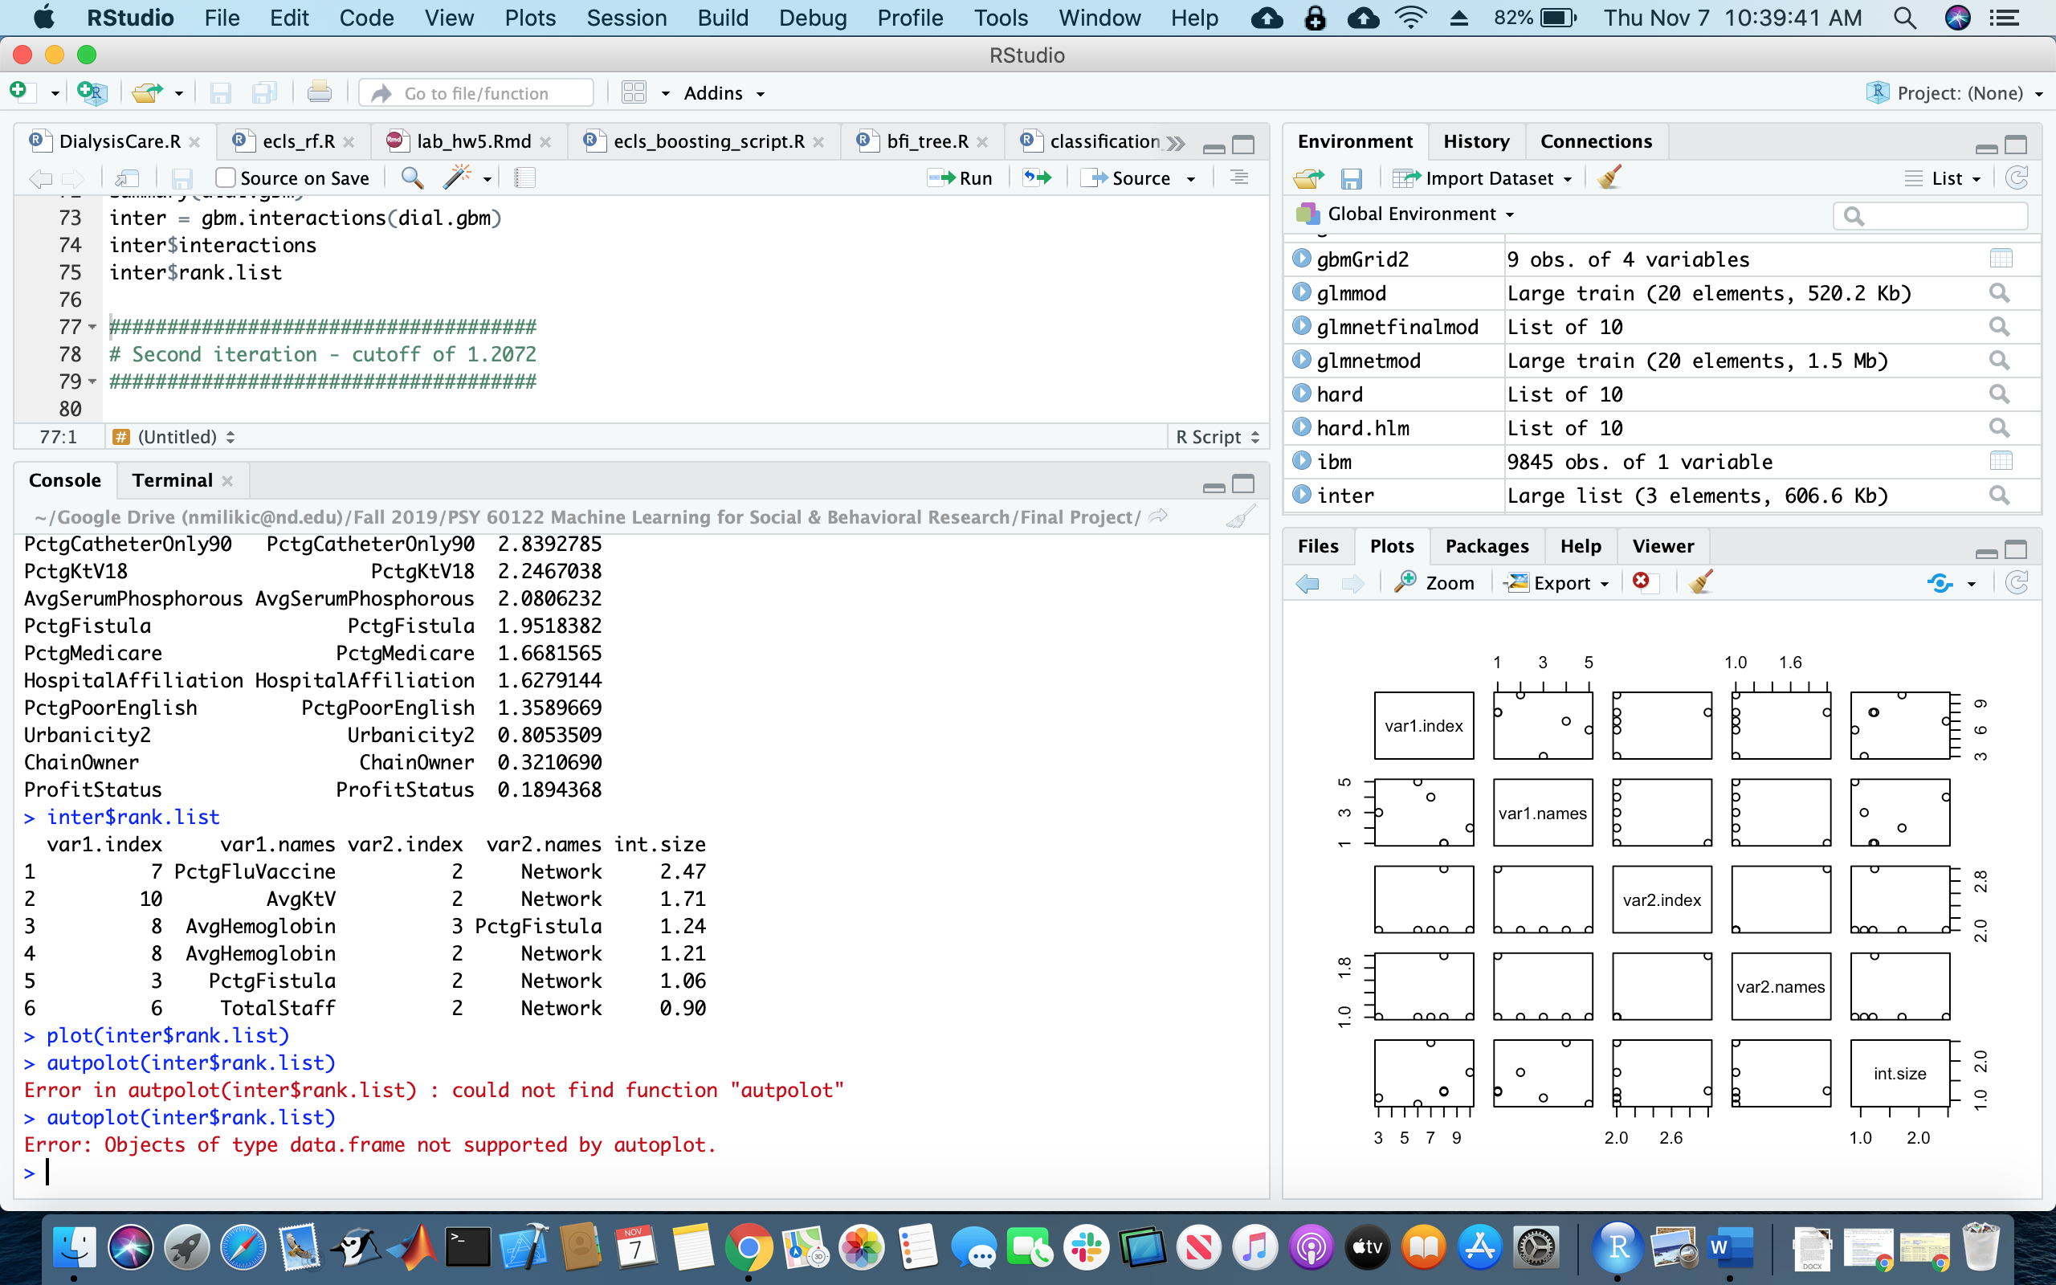

Figure 6: Variable Interactions from Boosting with SRR cut score 1.

|  |  |
| --- | --- |
| 1. Lasso   PctgBlack  Network  PctgFistula  PctgMedicare  PctgNonMedicare  ChainOwner  TotalStaff  PctgFluVaccine  AvgHemoglobin  PctgESAPrescribed  AvgKtV  PctgKtV18  PctgKtVOther | 1. Elastic Net   PctgBlack  Network  PctgFistula  PctgMedicare  PctgNonMedicare  TotalStaff  PctgFluVaccine  AvgHemoglobin  PctgESAPrescribed  AvgKtV  PctgKtV18  PctgKtVOther |

Figure 7: Variable Selection for lasso (a) and elastic net (b) for SRR cut score 1.2072.



Figure 8: CART Decision Tree for SRR cut score 1.2072.

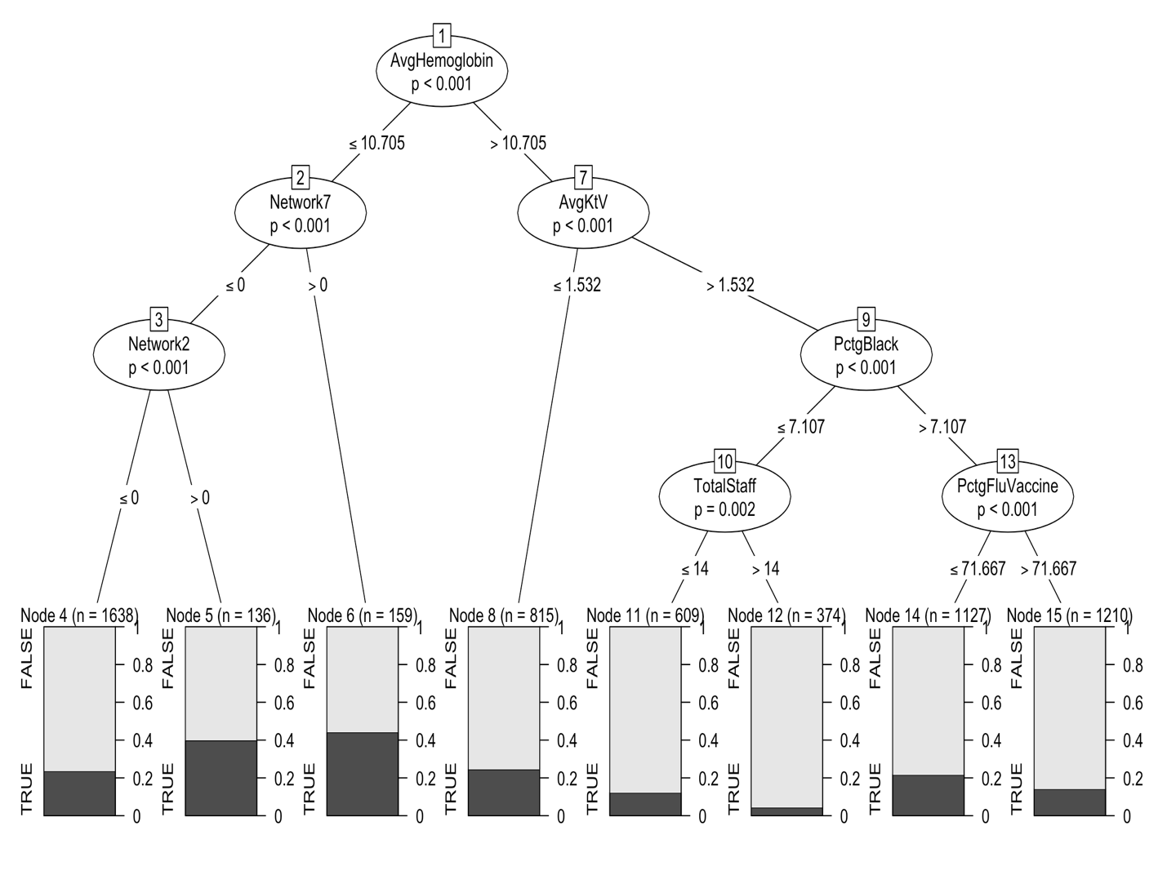

Figure 9: Conditional Inference Tree for SRR cut score 1.2072.

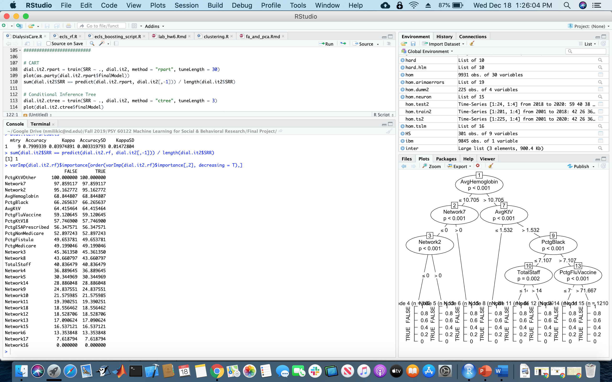

Figure 10: Variable Importance from CART Random Forest with SRR cut score 1.2072.

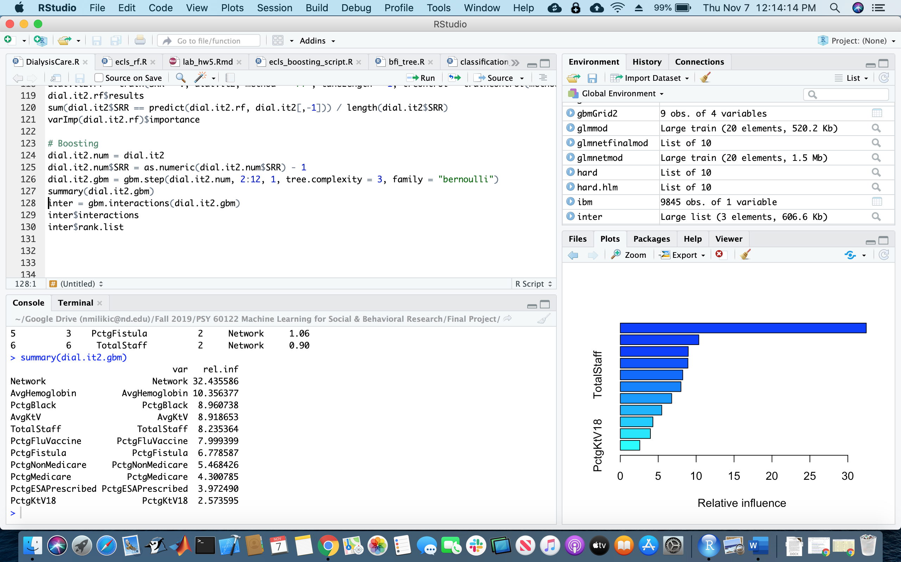

Figure 11: Relative Influence of Each Variable from Boosting with SRR cut score 1.2072.

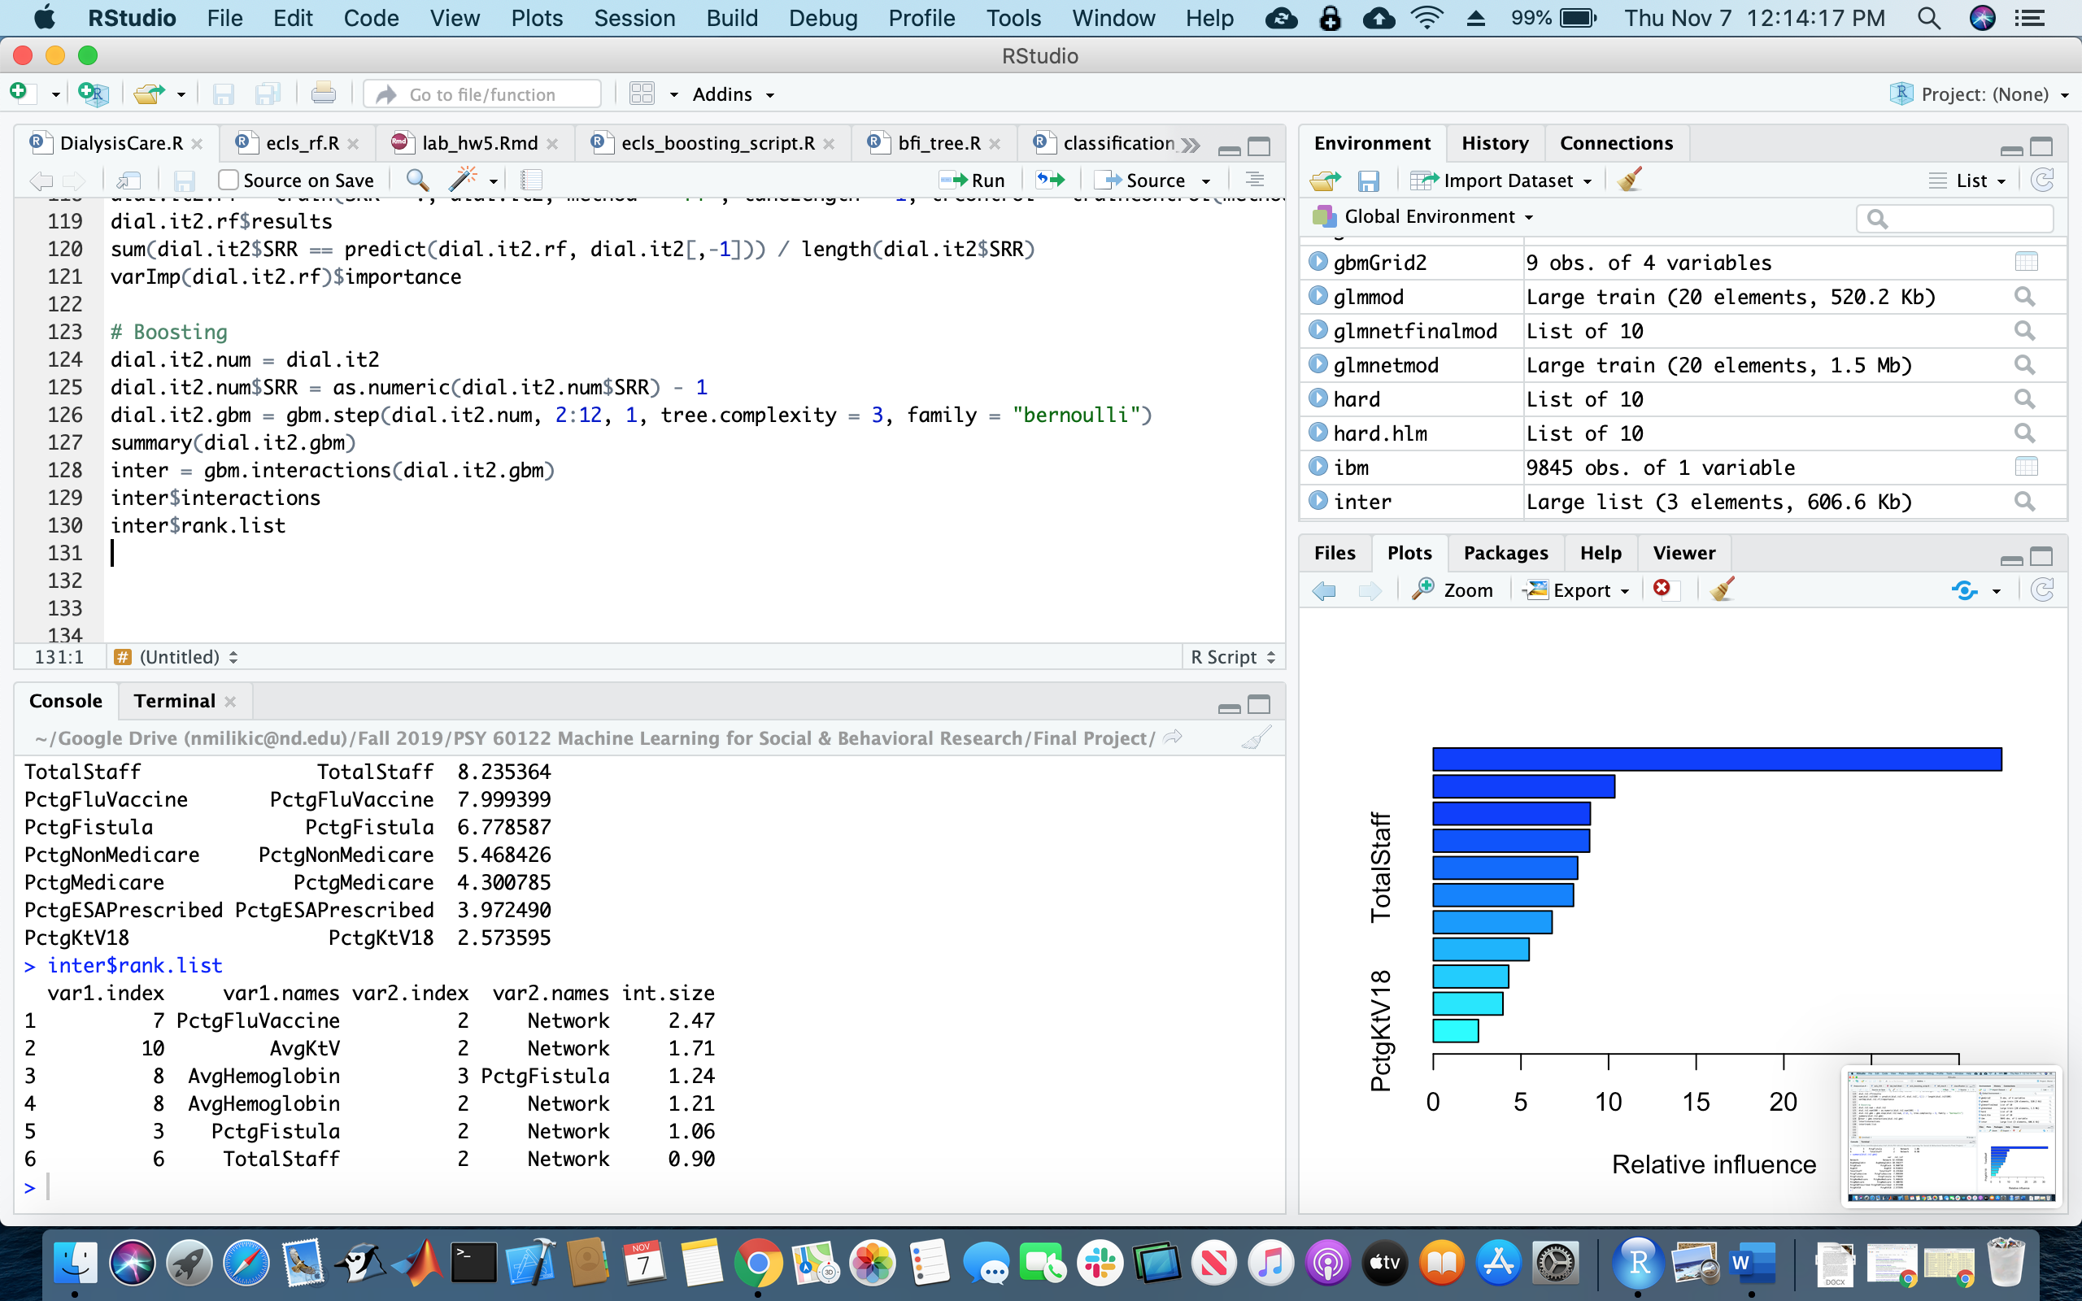

Figure 12: Variable Interactions from Boosting with SRR cut score 1.2072.

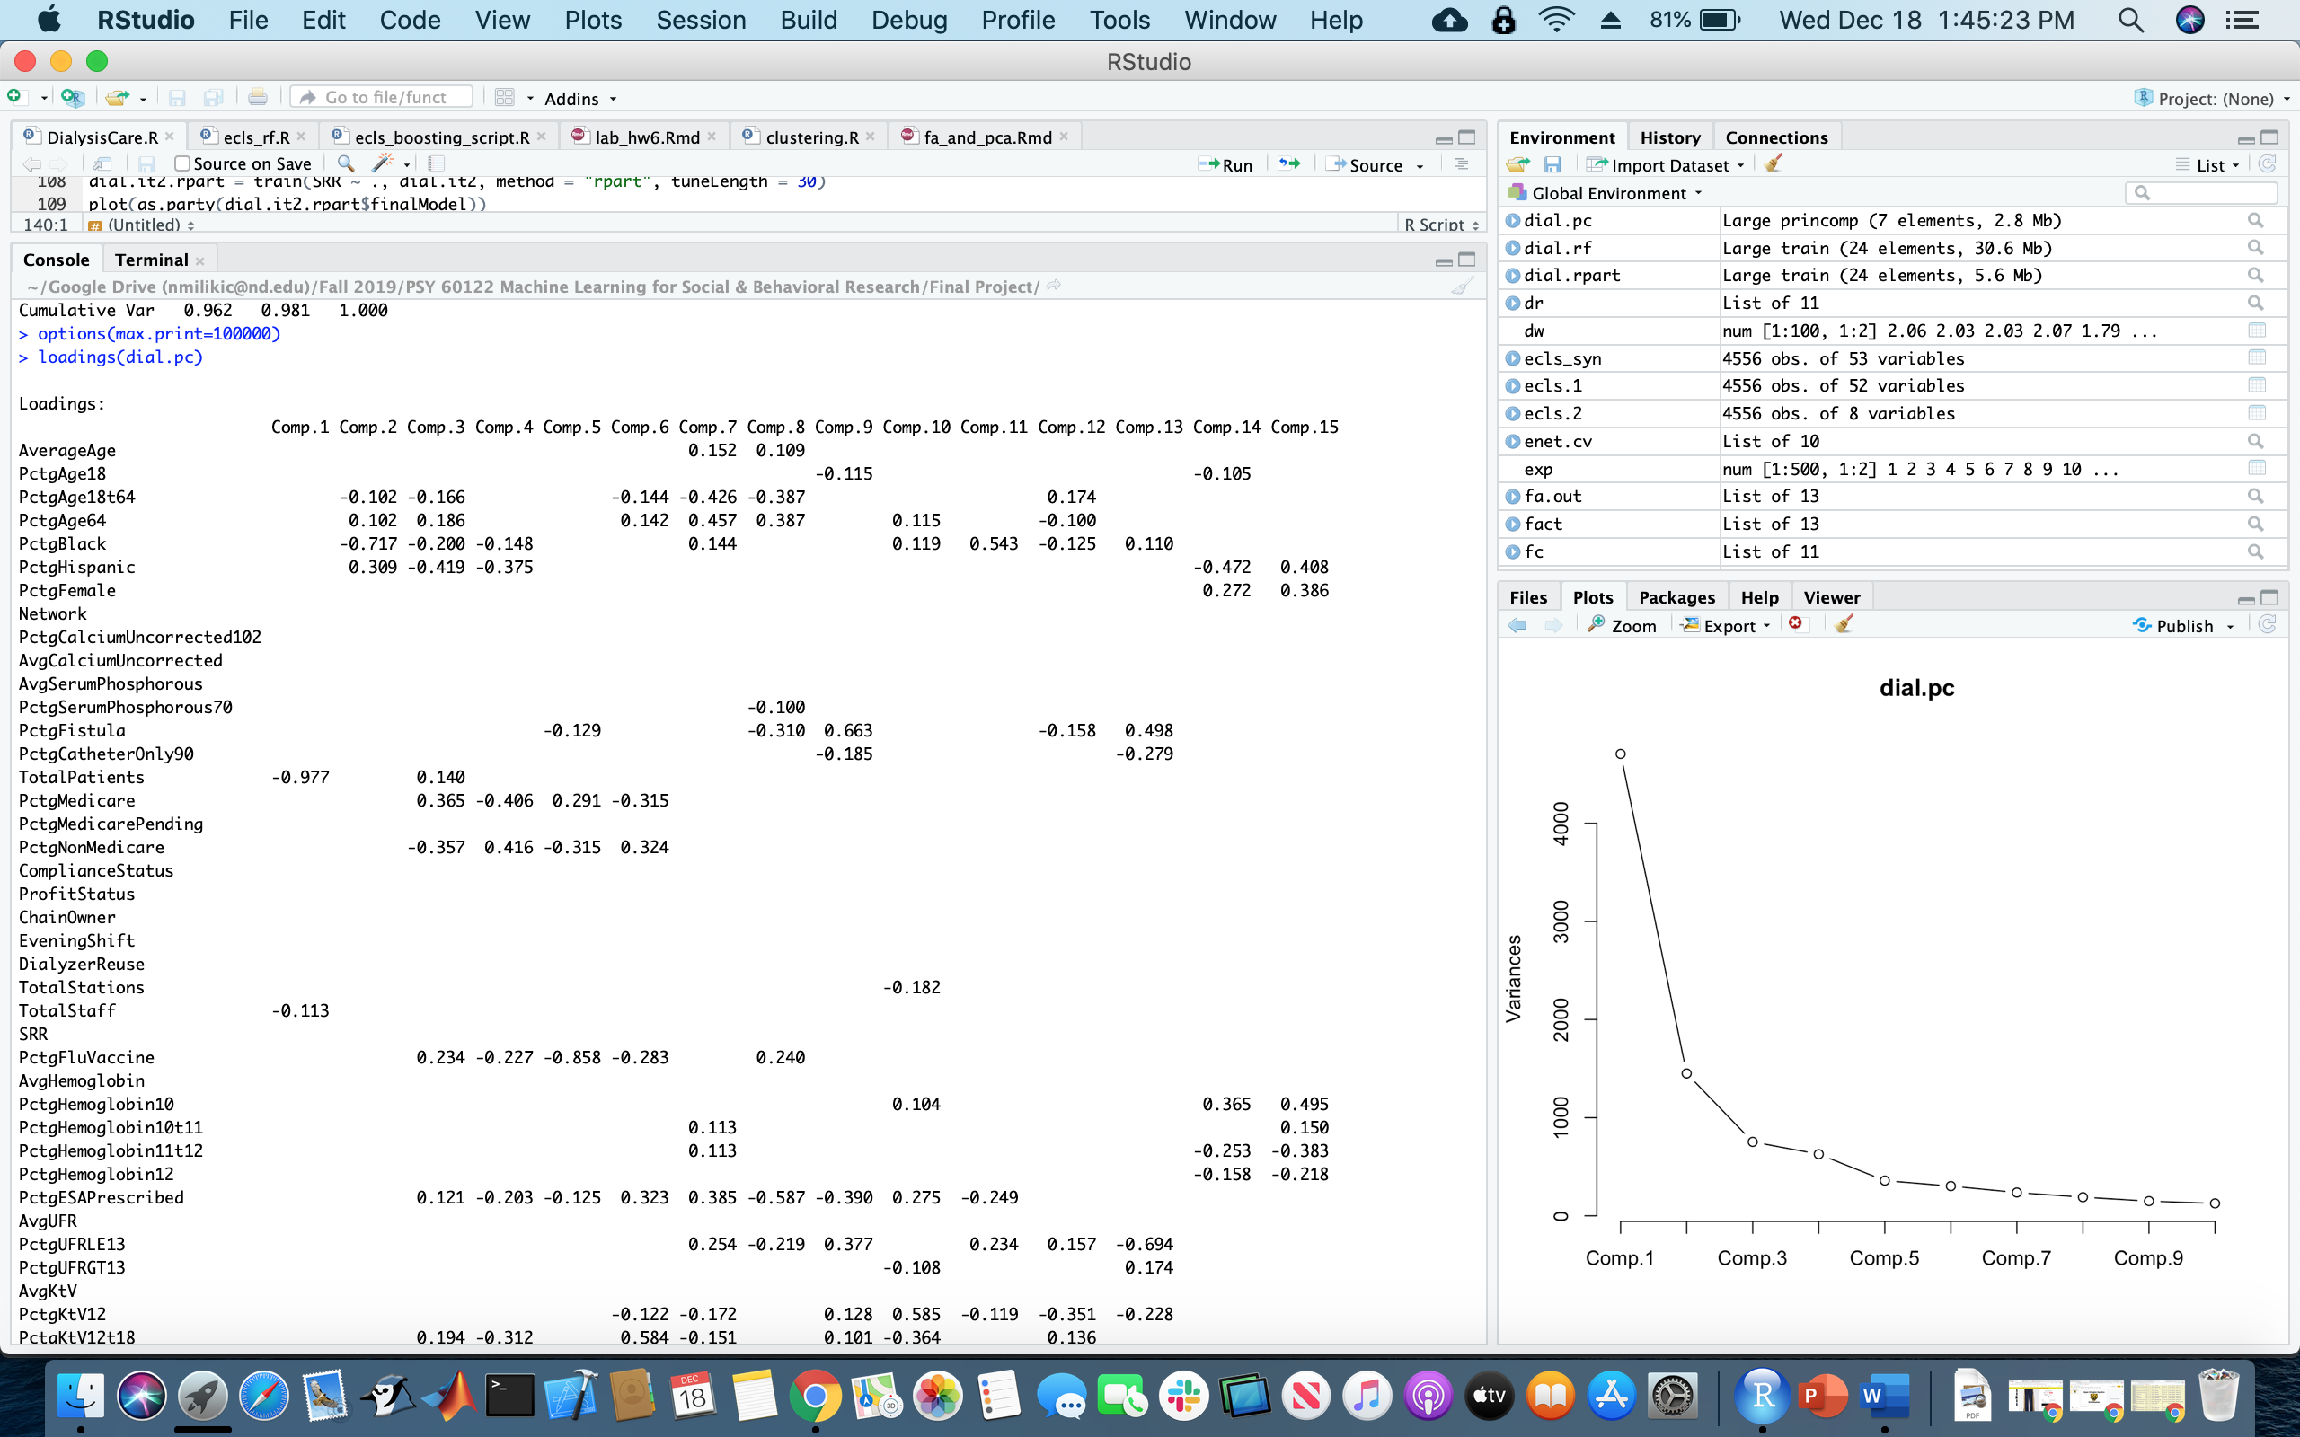

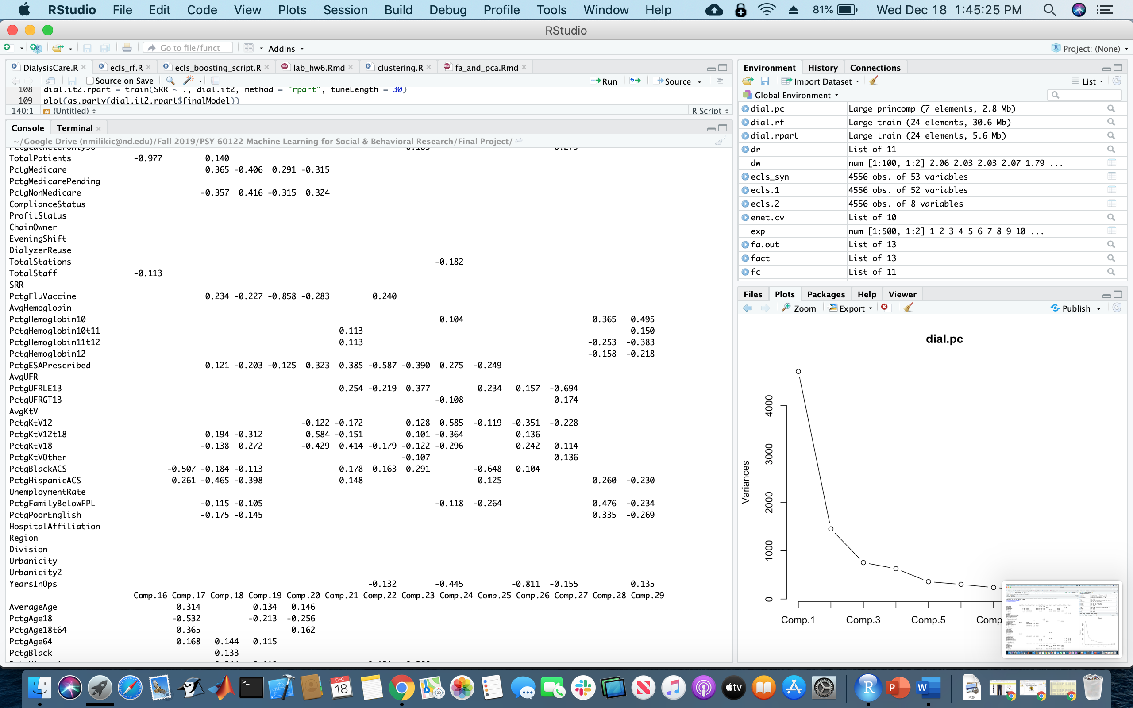

Figure 13: Loadings for a principal component analysis of the complete dataset.

|  |  |  |  |  |
| --- | --- | --- | --- | --- |
|  | CART (SRR > 1) | Conditional Inference (SRR > 1) | CART (SRR > 1.2072) | Conditional Inference (SRR > 1.2072) |
| Biological Markers | AvgHemoglobin  PctgESAPrescribed  PctgFluVaccine | AvgHemoglobin  AvgKtV  PctgHemoglobin10 |  | AvgHemoglobin  AvgKtV  PctgFluVaccine |
| Demographic | PctgBlack | Network  PctgBlack  TotalPatients  Urbanicity2 |  | Network  PctgBlack  TotalStaff |

Table 1: Variables chosen for nodes in each of the four decision trees created.

Appendix 2: Scripts

############################

# Importation and formatting

############################

setwd("~/Google\ Drive\ (nmilikic@nd.edu)/Fall\ 2019/PSY\ 60122\ Machine\ Learning\ for\ Social\ &\ Behavioral\ Research/Final\ Project/")

dial = read.csv(file = "DialysisCareQualityData.csv", header = TRUE, skip = 1, sep = ",", na.strings = c("","-"))

dim(dial)

dial = na.omit(dial)

dim(dial)

str(dial)

dial$Network = as.factor(dial$Network)

dial$TotalStations = as.integer(dial$TotalStations)

dial$ZipCode = as.factor(dial$ZipCode)

dial.complete = dial

dial = dial[,c(3,4,5,6,7,8,9,10,14,15,16,17,18,19,20,21,22,23,24,25,26,27,28,29,30,31,32,33,34,35,36,37,38,39,40,41,42,43,44,45,46,48,49,50,51,52,53,55,56,57,58,59)]

###############################

# First iteration - cutoff of 1

###############################

dial$SRR = as.factor(dial$SRR > 1)

####################

# Variable Selection

####################

# Lasso, 1SE rule

library(glmnet)

dial.mat = data.matrix(dial)

dial.lasso.cv = cv.glmnet(dial.mat[,-26], dial.mat[,26], family = "binomial", alpha = 1)

plot(dial.lasso.cv)

round(coef(dial.lasso.cv, dial.lasso.cv$lambda.1se), 5)

# Elastic net, 1SE rule

dial.enet.cv = cv.glmnet(dial.mat[,-26], dial.mat[,26], family = "binomial", alpha = 0.5)

plot(dial.enet.cv)

round(coef(dial.enet.cv, dial.enet.cv$lambda.1se), 5)

# Using variables selected from lasso and elastic net

# The full data matrix is still stored in dial.complete

dial = dial[,c("SRR","PctgBlack","Network","AvgSerumPhosphorous","PctgFistula","PctgCatheterOnly90","TotalPatients","PctgMedicare","PctgNonMedicare","ProfitStatus","ChainOwner","PctgFluVaccine","AvgHemoglobin","PctgHemoglobin10","PctgESAPrescribed","AvgKtV","PctgKtV18","PctgKtVOther","PctgPoorEnglish","HospitalAffiliation","Urbanicity2")]

##########################

# Decision Tree Algorithms

##########################

# CART

library(partykit)

library(caret)

dial.rpart = train(SRR ~ ., dial, method = "rpart", tuneLength = 30)

plot(as.party(dial.rpart$finalModel))

sum(dial$SRR == predict(dial.rpart, dial[,-1])) / length(dial$SRR)

# Conditional Inference Tree

dial.ctree = train(SRR ~ ., dial, method = "ctree", tuneLength = 3)

plot(dial.ctree$finalModel)

sum(dial$SRR == predict(dial.ctree, dial[,-1])) / length(dial$SRR)

# CART Random Forest

dial.rf = train(SRR ~ ., dial, method = "rf", tuneLength = 1, trControl = trainControl(method = "cv", number = 10), importance = T)

dial.rf$results

sum(dial$SRR == predict(dial.rf, dial[,-1])) / length(dial$SRR)

varImp(dial.rf)$importance[order(varImp(dial.rf)$importance[,2], decreasing = T),]

# Boosting

library(grf)

library(dismo)

dial.num = dial

dial.num$SRR = as.numeric(dial.num$SRR) - 1

dial.gbm = gbm.step(dial.num, 2:21, 1, tree.complexity = 3, family = "bernoulli")

summary(dial.gbm)

inter = gbm.interactions(dial.gbm)

inter$interactions

inter$rank.list

#####################################

# Second iteration - cutoff of 1.2072

#####################################

dial.it2 = dial.complete[,c(3,4,5,6,7,8,9,10,14,15,16,17,18,19,20,21,22,23,24,25,26,27,28,29,30,31,32,33,34,35,36,37,38,39,40,41,42,43,44,45,46,48,49,50,51,52,53,55,56,57,58,59)]

dial.it2$SRR = as.factor(dial.it2$SRR > 1.2072)

####################

# Variable Selection

####################

# Lasso, 1SE rule

dial.it2.mat = data.matrix(dial.it2)

dial.it2.lasso.cv = cv.glmnet(dial.it2.mat[,-26], dial.it2.mat[,26], family = "binomial", alpha = 1)

plot(dial.it2.lasso.cv)

round(coef(dial.it2.lasso.cv, dial.it2.lasso.cv$lambda.1se), 5)

# Elastic net, 1SE rule

dial.it2.enet.cv = cv.glmnet(dial.it2.mat[,-26], dial.it2.mat[,26], family = "binomial", alpha = 0.5)

plot(dial.it2.enet.cv)

round(coef(dial.it2.enet.cv, dial.it2.enet.cv$lambda.1se), 5)

# Using variables selected from lasso and elastic net

# The full data matrix is still stored in dial.it2.complete

dial.it2 = dial.it2[,c("SRR","PctgBlack","Network","PctgFistula","PctgMedicare","PctgNonMedicare","TotalStaff","PctgFluVaccine","AvgHemoglobin","PctgESAPrescribed","AvgKtV","PctgKtV18","PctgKtVOther")]

##########################

# Decision Tree Algorithms

##########################

# CART

dial.it2.rpart = train(SRR ~ ., dial.it2, method = "rpart", tuneLength = 30)

plot(as.party(dial.it2.rpart$finalModel))

sum(dial.it2$SRR == predict(dial.it2.rpart, dial.it2[,-1])) / length(dial.it2$SRR)

# Conditional Inference Tree

dial.it2.ctree = train(SRR ~ ., dial.it2, method = "ctree", tuneLength = 3)

plot(dial.it2.ctree$finalModel)

sum(dial.it2$SRR == predict(dial.it2.ctree, dial.it2[,-1])) / length(dial.it2$SRR)

# CART Random Forest

dial.it2.rf = train(SRR ~ ., dial.it2, method = "rf", tuneLength = 1, trControl = trainControl(method = "cv", number = 10), importance = T)

dial.it2.rf$results

sum(dial.it2$SRR == predict(dial.it2.rf, dial.it2[,-1])) / length(dial.it2$SRR)

varImp(dial.it2.rf)$importance[order(varImp(dial.it2.rf)$importance[,2], decreasing = T),]

# Boosting

dial.it2.num = dial.it2

dial.it2.num$SRR = as.numeric(dial.it2.num$SRR) - 1

dial.it2.gbm = gbm.step(dial.it2.num, 2:12, 1, tree.complexity = 3, family = "bernoulli")

summary(dial.it2.gbm)

inter = gbm.interactions(dial.it2.gbm)

inter$interactions

inter$rank.list

######################

# Principal Components

######################

dial.pc = princomp(data.matrix(dial.complete[,c(3,4,5,6,7,8,9,10,14,15,16,17,18,19,20,21,22,23,24,25,26,27,28,29,30,31,32,33,34,35,36,37,38,39,40,41,42,43,44,45,46,48,49,50,51,52,53,55,56,57,58,59)]))

summary(dial.pc)

plot(dial.pc, type = "lines")

loadings(dial.pc)